**CONCEPT DOCUMENT FOR A**

**MINI SUPER-MARKET MANAGEMENT SYSTEM.**

**INTRODUCTION**

The Mini Super Market Management System is a system that deals with Super market automation which deals with both selling and purchasing of items. This project is designed with the aim of making the existing system more reliable, informative and effective.

**Objectives of the system**

1. To ensure the daily functioning of the supermarket is smooth. This also be referred to as the buying and selling of goods.

2.To ensure accurate statistics(Quantity Price)of a specific product item.

3. For easy recording of goods in store and proper identification of this goods.

4.Impove the credibility of the accounts department. Reduce and stop theft of products/cash, through billing.

**Limitations of the current System**

**Very slow**

The current speed of the manual system is slow and ambiguous due to the involvement of a large volume of data.

**Insecurity**

Data recorded in files and papers kept in cabinets and shelves are highly likely to be stolen or reached upon by unauthorized personal. Therefore compromising the accounting the department as an example.

**Hard to access**

The searching of data manually is more hectic and difficult due to the large bilk of documentation required.

**Expensive**

The current manual system is very hard to maintain due to the large expense of e.g paper which rarely last over long periods of time

**Advantages of the proposed system**

**High speeds**

The new system will be have high processing system that will ensure that time wasted in recoding manual issues of the supermarket shall be usefully spent at other ventures.

**It is secure**

The new proposed system will see to it that each member working in the supermarket will receive their own password to access the system. The passwords and usernames will ensure that members of certain departmental levels access data which they r authorized to view.

**Easily accessible**

The new proposed system will be as such due to the fact that cloud data storage will be used other than the filling system.

**Cheaper**

In the short run the system will be expensive to install and implement but in the long run the cost incurred will be lower than that of the current manual system.

**Scope of the system**

This research work covers stock control, management and tends to correct anomalies in Mini Supermarket business. It analyses opening of new incoming stocks, stock updates and ability to view existing ones. It provides quick way of operation by capturing the manual process and automating them. This project is helpful to computerize the item transaction, sales activity record keeping which is a very huge task and maintaining the stock

**MODULES**

**Administrative Module**

System Administrator can add any new items present in the supermarket. He also has the right to modify or delete it from the database and also query the database to obtain records.

**Employee Module**

When a new employee joins the company, the administrator saves his record in the database. An employee will not be able to have certain privileges such as the admin.

**Purchase Module**

This involves recording the purchasing of stock from various suppliers. Ensuring that suppliers are right on time in their deliveries and that no supplier is over/under paid for their services.

**Sales Module**

Removing of items from database once they are sold and generating of receipts to customers. Thus

ensuring the credibility of the accounts department.

**Billing Module**

Preparing and sending invoices from records obtained from the purchases and sales. The billing

ensures that the tracking of stock of goods is easier and that there is no over stocking or under

stocking of goods.

**Mockup Designs/Interfaces**

**User Login**

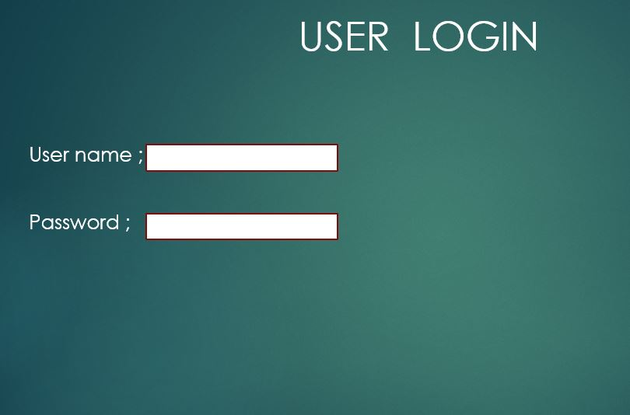

**Employee portal**

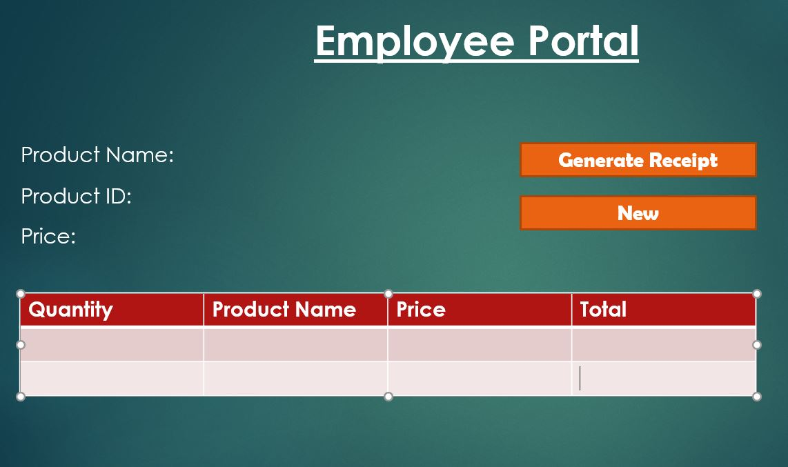

**Administrator Portal**

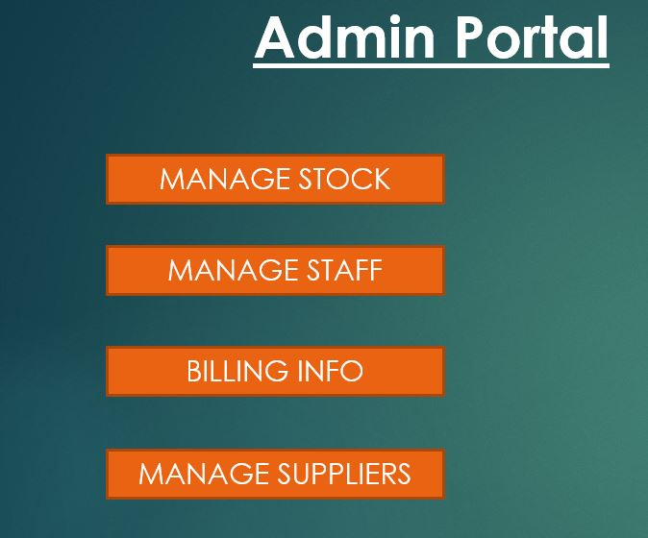

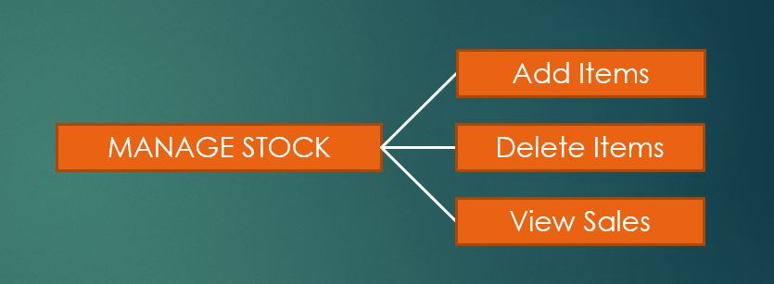

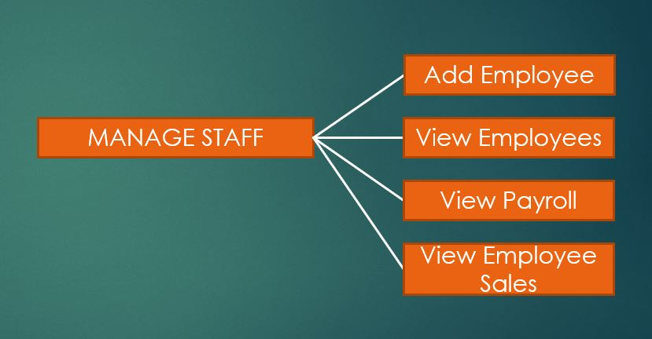

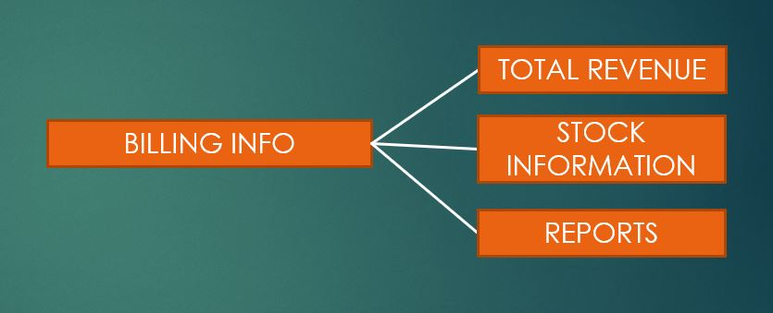

**Database schema**

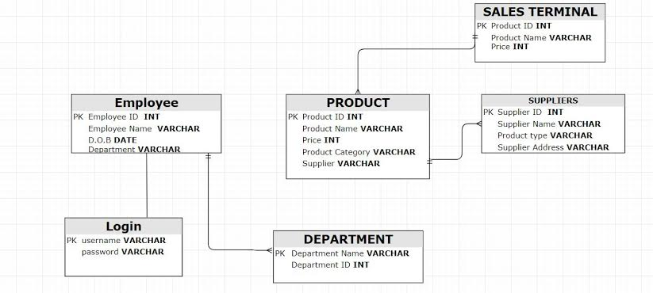

**Database Management System**

The most suitable Database Management System to be used for this project is SQL due to the following reasons;

**WHY SQL ?**

1. It is efficient in retrieving large amounts of Data.
2. SQL joins two or more tables to show it as one table.
3. SQL makes it easier to manage a database system without having to write a substantial amount of code

**HOW TO CONNECT SQL TO JAVA ?**

1. Establishing a connection with the data source you want to use
2. Using the DriverManager Class

- Getting the correct JDBC driver for your database.

-Using Connection Object

1. use a terminal/console window to output the results from a database.
2. Adding these import Statements to the top of the code

*-import java.sql.Connection;*

*-import java.sql.DriverManager;*

*-import java.sql.SQLException;*